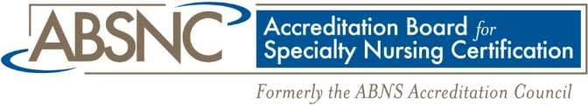
Dottie Roberts, EdD, MSN, MACI, RN, OCNS-C, CMSRN
Accreditation Manager
205-795-7127
absnc@nursingcertification.org

FOR IMMEDIATE RELEASE

ABSNC Launches New Accreditation Standards
For Portfolio Assessment and Assessment-Based Certificate Programs

BIRMINGHAM, AL December 21, 2016 —The Accreditation Board for Specialty Nursing Certification, Inc. (ABSNC), announces the development and launch of two new sets of accreditation standards: Portfolio Assessment Certification and Assessment-Based Certificate Programs. Nursing organizations with programs that offer a portfolio assessment certification or an assessment-based certificate program may now earn ABSNC accreditation as a highly desirable distinction to validate the quality of these specialty programs.
A portfolio assessment is a purposeful collection of materials that authentically document the candidate’s knowledge, skills, understanding, and application of professional nursing practice and theory in a defined specialty area. The portfolio should include candidate self-reflection that demonstrates his or her metacognitive ability.
An assessment-based certificate program is a non-degree granting program that provides evidence-based education on a narrow subset of knowledge and skills that adds value to the clinician and the healthcare consumer. A certificate is awarded on completion of the education program and successful performance on an outcomes-based assessment, not for attendance only.
ABSNC accreditation is a peer-reviewed mechanism that allows specialty nursing organizations to be recognized for demonstrating compliance with the highest quality standards in the industry for certification and certificate programs. Accreditation of examination-based nursing certification programs has been offered through the ABNS Accreditation Council and subsequently ABSNC for more than 25 years.
“Through accreditation, applicant organizations complete a rigorous process to demonstrate development and maintenance of quality programs. Organizational leaders and credential holders can be justifiably proud of earning this prestigious recognition,” said Dottie Roberts, EdD, MSN, MACI, RN, OCNS-C®, CMSRN®, ABSNC Accreditation Manager.
ABSNC is the only accrediting body specifically for nursing certification. Currently ABSNC accredits more than 60 certification programs from 20 specialty nursing certification organizations. The Board offers accreditation standards for three types of programs: Examination-Based Certification Programs, Portfolio Assessment Certification Programs, and Assessment-Based Certificate Programs. For more information about ABSNC and its accreditation standards, please visit www.nursingcertification.org (> About ABSNC) or contact Dottie Roberts, ABSNC Accreditation Manager (absnc@nursingcertification.org, 205-795-7127).

###

